Topic SQL

STEP 1: Create a Database

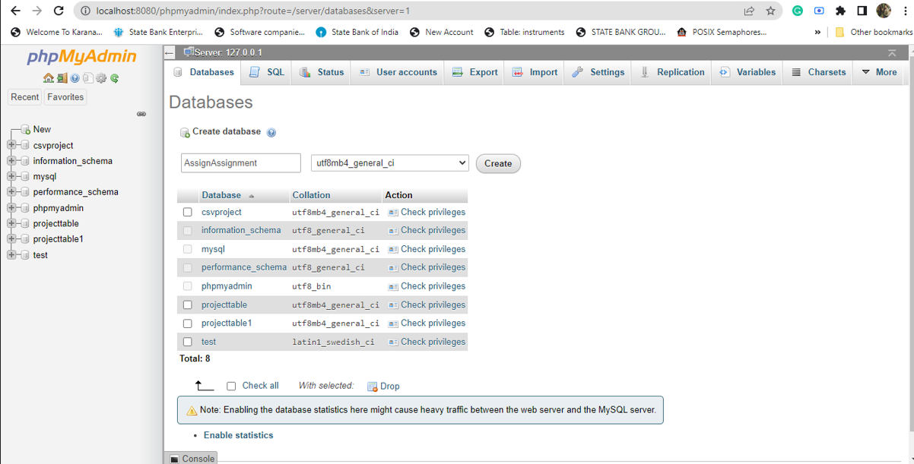

STEP 2: Create a Table Student.

Sql query:

CREATE TABLE STUDENT(

EnrollMent_Number INT NOT NULL PRIMARY KEY,

STUDENT VARCHAR(10),

Section VARCHAR(10),

Subject_id VARCHAR(10),

MARKS INT);

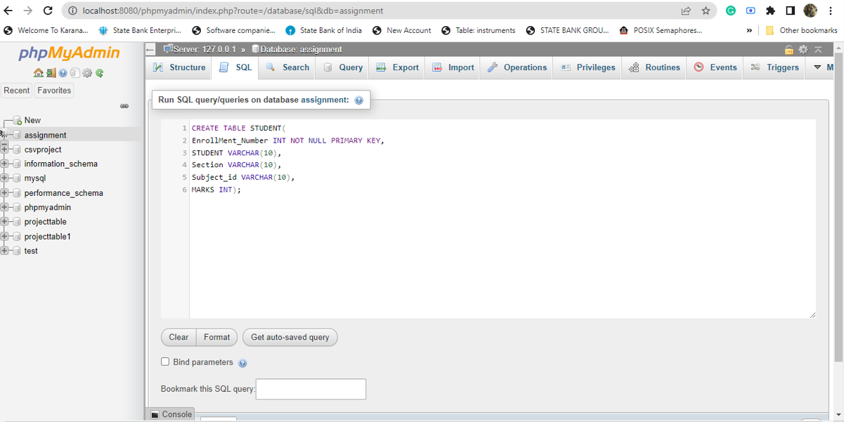

Step 3: Insert Data into the table

Sql query:

INSERT INTO STUDENT VALUES(1,'Tim','A',1,70);

INSERT INTO STUDENT VALUES(2,'Jim','A',2,75);

INSERT INTO STUDENT VALUES(3,'Kim','B',3,65);

INSERT INTO STUDENT VALUES(4,'Tom','B',4,77);

INSERT INTO STUDENT VALUES(5,'John','C',5,60);

INSERT INTO STUDENT VALUES(6,'Joe','C',1,82);

INSERT INTO STUDENT VALUES(7,'James','B',2,76);

INSERT INTO STUDENT VALUES(8,'Henry','C',5,68);

INSERT INTO STUDENT VALUES(9,'Matt','B',3,71);

INSERT INTO STUDENT VALUES(10,'Paul','A',4,79);

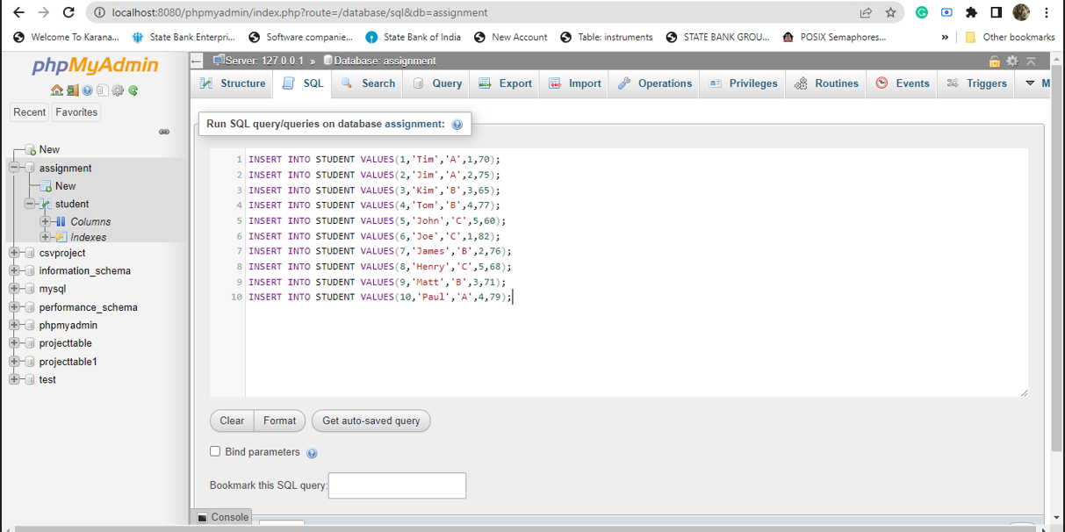

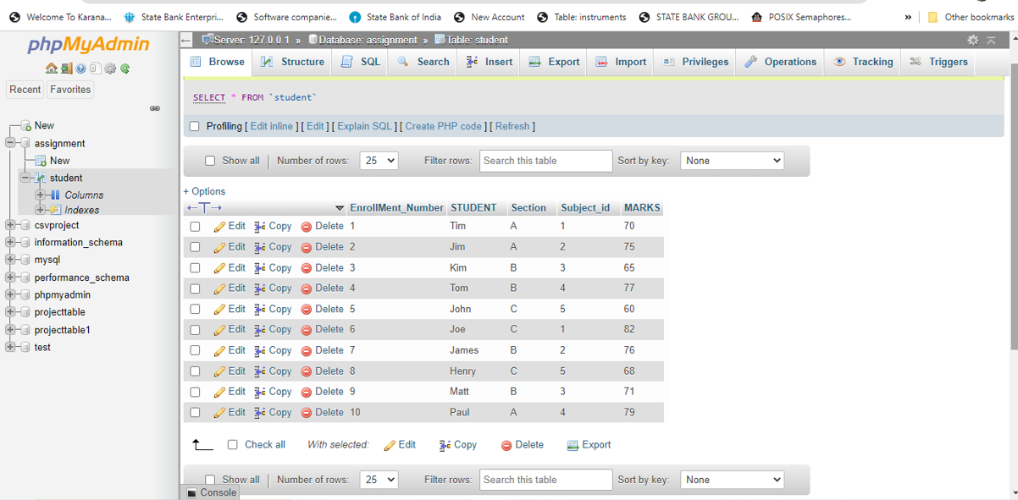

Step 4:

SQL query to print the section-wise Number of candidates who have secured more than or equal to 75 marks in the Semester Exam.

SELECT section, COUNT(section) AS "No.of Candidate greater or equal to 75 marks" FROM STUDENT WHERE marks>=75 GROUP BY section;

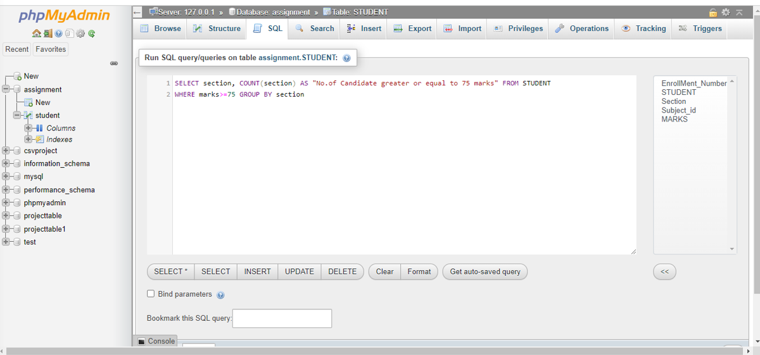

Result:

